Task2 : Write a Map Reduce program to calculate the total units sold for each Company.

Mapper:

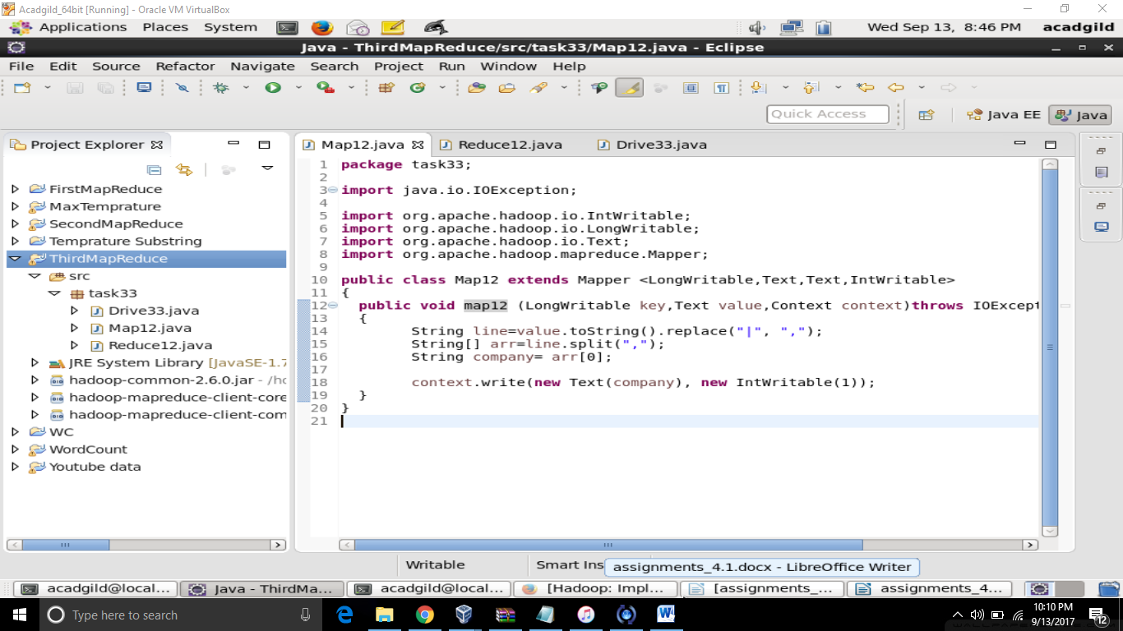

Reducer:

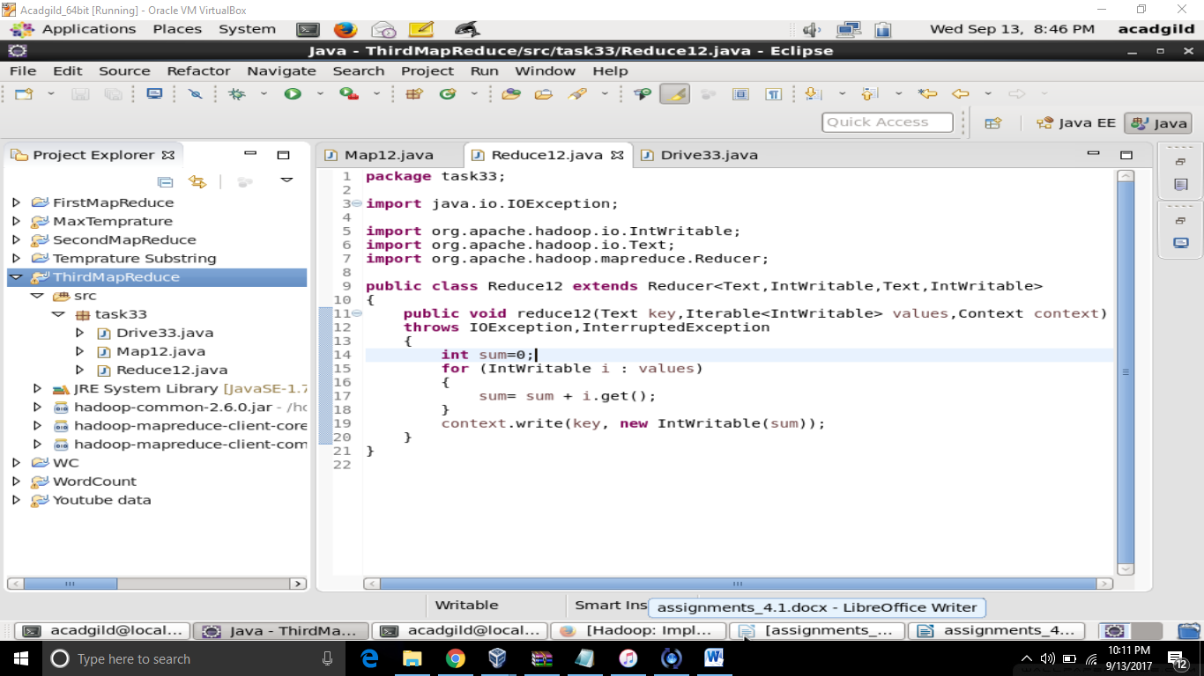

Driver:

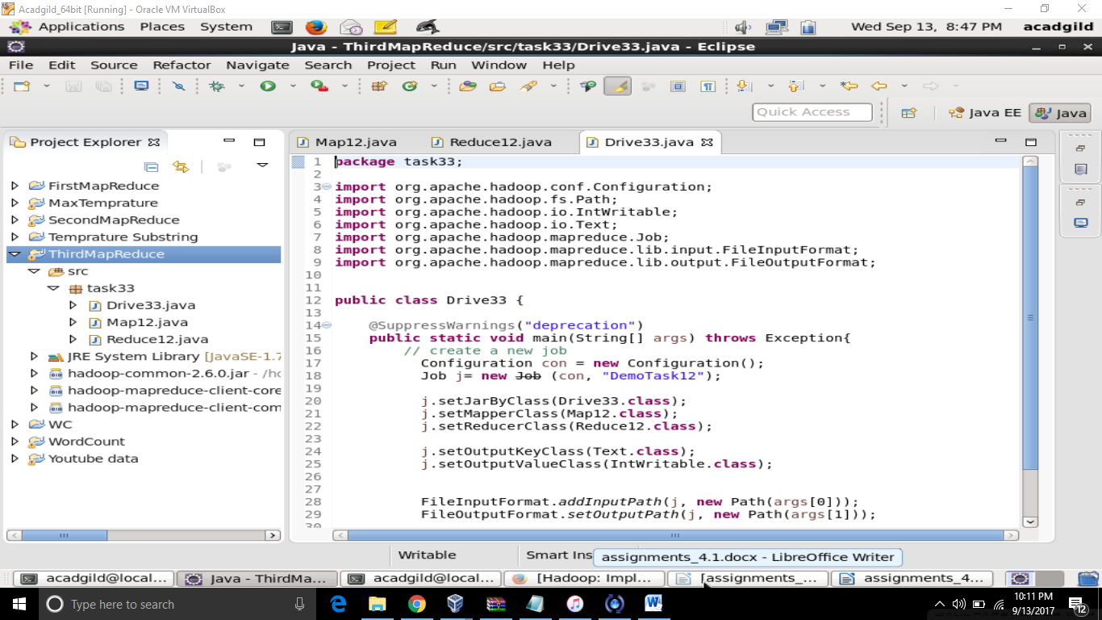

JAR Execution:

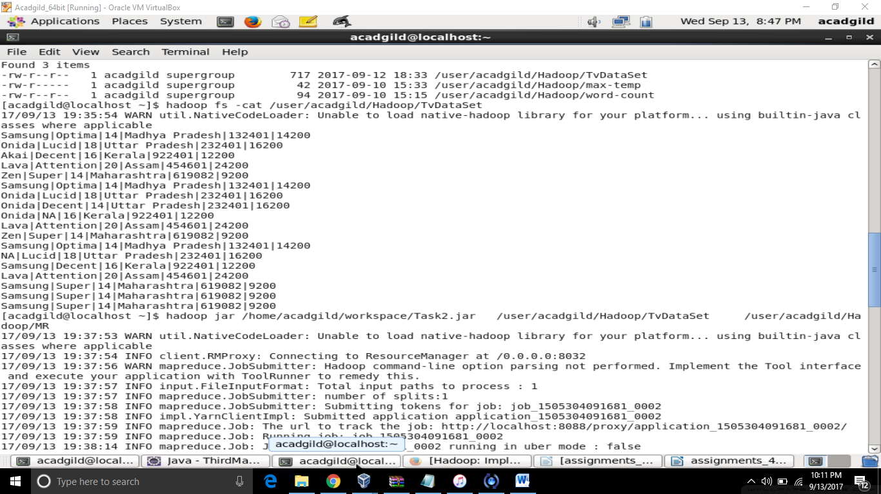

Output:

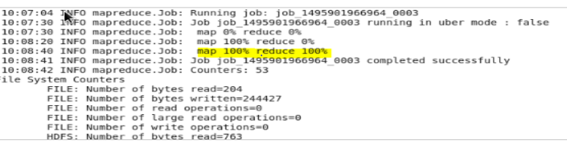

Task 3: Write a Map Reduce program to calculate the total units sold in each state for Onida

company.

Mapper:

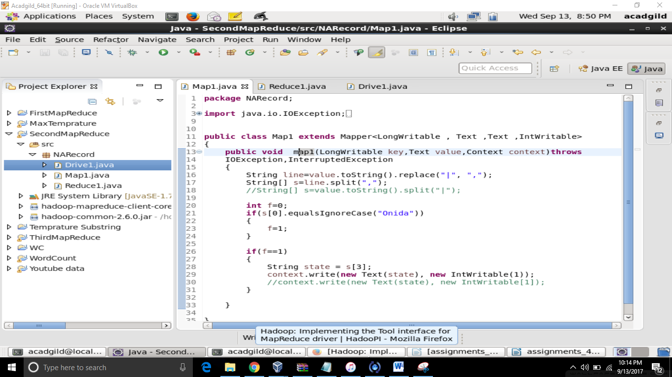

Reducer:

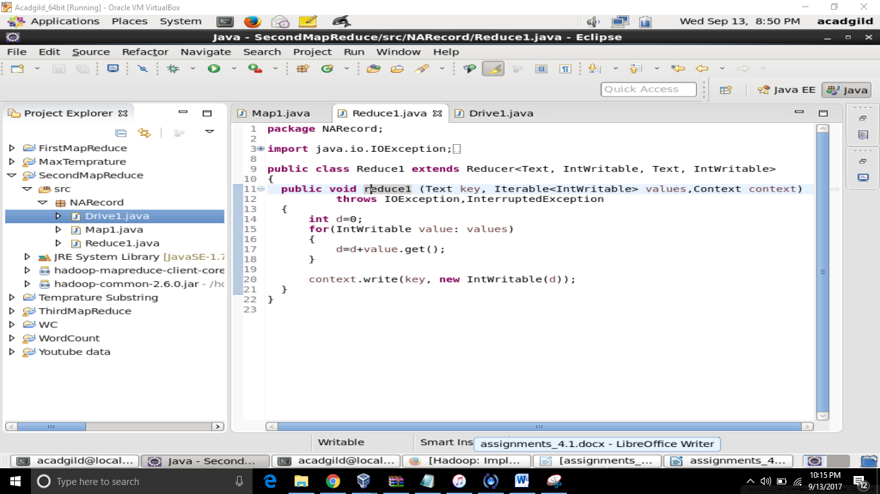

Driver:

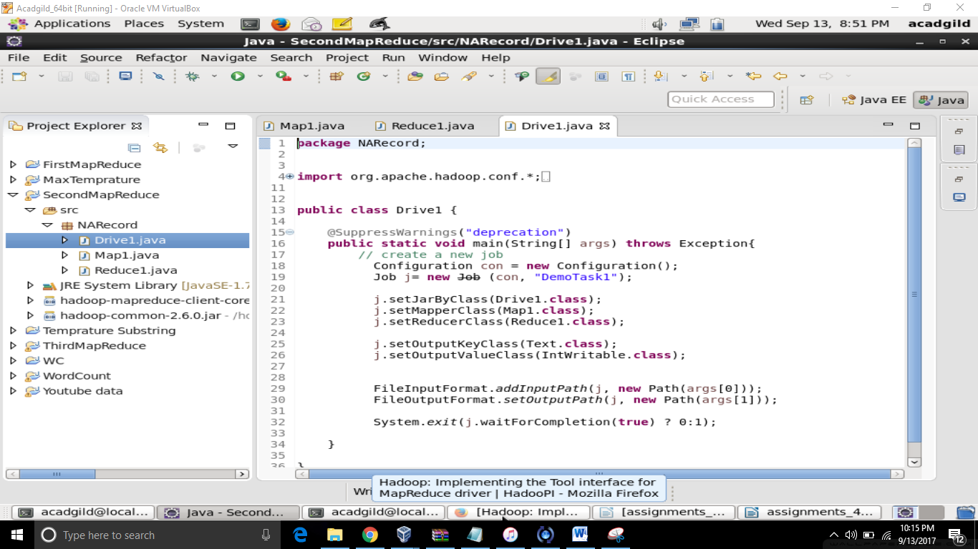

Output:

